## JS Back-End Exam – Myth & Legends

## Exam Rules:

1. You have **6 hours**.
2. When you are ready, delete the ***node_modules***folder, make sure all dependencies are listed in the ***package.json*** file and submit your archiving project.
3. You must use the provided HTML & CSS resources.
4. You may **add attributes** (such as **class** and **dataset**), but it is forbidden to **change** **existing** attributes (such as **class** and **id**).
5. You may **change "href"** attributes on links and add/change the **method** and **action** attributes of HTML Forms.
6. Use **Express.js** as a back-end framework.
7. Use **MongoDB** as a database with [**mongoose**](https://mongoosejs.com/docs/)**.**
8. You can use whatever **view engine** you like ([**express-handlebars**](https://www.npmjs.com/package/express-handlebars), EJS, Pug, etc.).
9. Use [**bcrypt**](https://www.npmjs.com/package/bcrypt) **for hashing the password.**
10. It is **forbidden** to **use** **React**, **Vue**, **Angular,** etc.
11. All applications will be **examined** as follows:
    * The needed **dependencies** are installed with the command "**npm install**".
    * The application is **started** with the command "**npm run start**".
12. The examiners are **NOT** allowed to **change** anything in your code and will **NOT** use any **instruments** **outside** of the course scope.
13. You decide how to name your links.

**IMPORTANT:**

**1. THE APPLICATION MUST START FROM THE FILE "INDEX.JS" ON PORT 3000!**

**2. ONLY THE LAST SUBMISSION WILL BE EVALUATED!**

## Application Overview

Get acquainted with the provided **HTML and CSS** and create an application for the **myths and legends**.

The visitors can **view** the **Home page** and **Dashboard** page with available myths. They can also **register** with an **email** and **password**, allowing them to create their posts and to **like a myths and legends they are interested in** (if the **current user** is **not** the author of the post). Authors can edit or delete their post at any time.

## Functional Requirements

### Guest (Not logged in)

**Guest** navigation example:

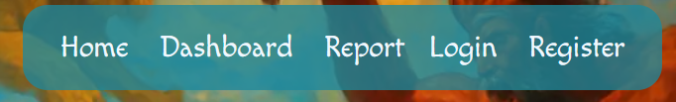

The **application** should provide Guest (not logged in) users with the functionality to Login, Register, and **view** the Home page, **Dashboard** page, **Report** page and **Details** page.

### Users (Logged in)

**User** navigation example:



The **application** should provide **Users** (logged in) with the functionality to:

* **View the Home page and all other pages with logged-in navigation**
* **View Dashboard page**
* **View Report page**
* **Create а new Myth Post [Add Myth]**
* **Access details page [Details]**
* **Like myths and legends post (**if the **current user** is **not** the **owner of the post)**
* **Delete or Edit the myths and legends myths depending on the user's authentication (only for the owner of the current post)**

## Database Models

The **Database** of the **Myths and Legends** application needs to support **two entities**:

### User

* email - string (required),
* password - string (required)

### Myths

* **name - string (required),**
* **origin - string (required),**
* **role - string (required),**
* **image: string (required),**
* **symbol: string (required),**
* **era: string (required),**
* **description: string (required),**
* **likedList - a collection of Users (a reference to the User model)**
* **owner - object ID (a reference to the User model)**

**Note:** When a user **liked myth or legend**, their **id** is added to the **likedList** collection. You can add more entities, if you need.

Implement the entities with the correct data types.

## Application Pages

#### Home Page (For logged in users and logged-out users)

Visualize **the last 3 added post. Each myth must** show information about the **myth name**, **origin, image** as well as a page with **details** about the **specific myth.**

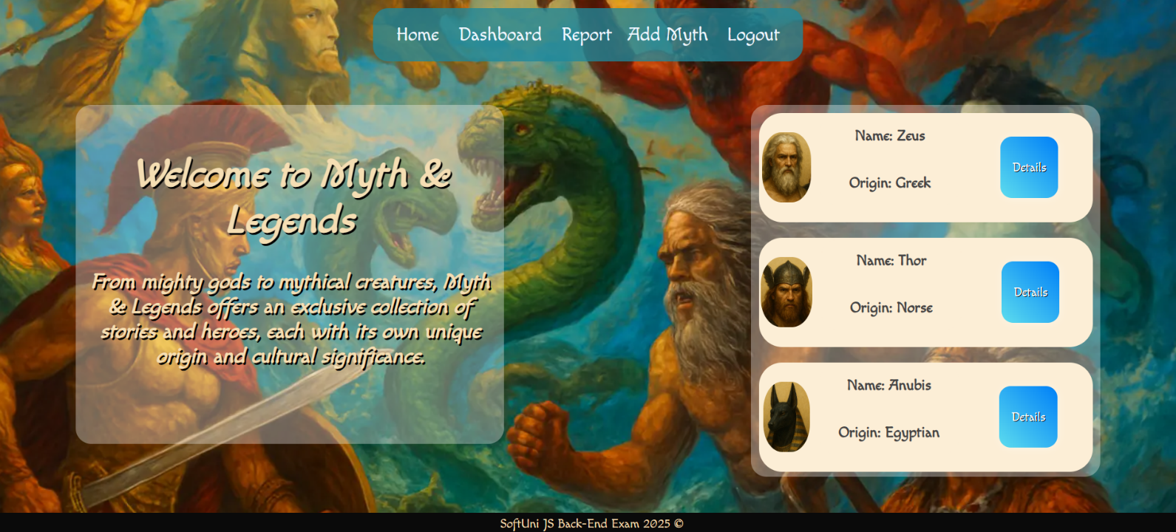

If there are **NO** myths in the database yet, display **"There are no myths and legends!"**

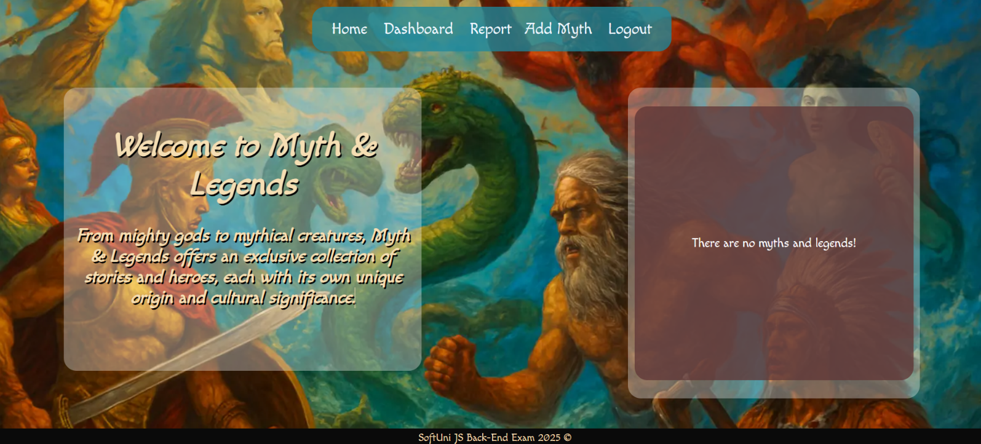

#### Register Page (Logged Out User)

**Register** a user inside the database with an **email and password**. The **password** inside the **database** must be hashed (**use bcrypt**), and both passwords **must match**! After **successful** registration, the user should be logged and **redirected** to the **Home page**.If the user tries to submit **invalid data**, an **error message** should be displayed and the already entered **data should be kept** in the input fields (except for the passwords).

A user who is already logged in should **NOT** be able to reach this page by typing its URL (e.g. "http://localhost:3000/register") in the browser address bar.

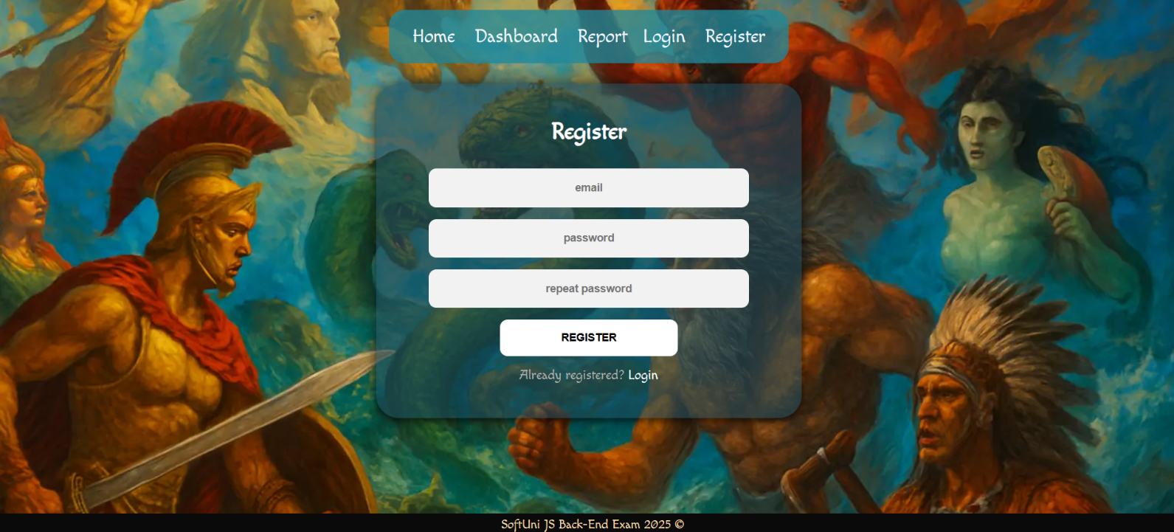

#### Login Page (Logged Out User)

Logging an already registered user with the correct **email** and **password**. After successful login, you should **redirect the user to the Home page.** If the user tries to submit **invalid data**, an **error message** should be displayed and the already entered **data should be kept** in the input fields (except for the passwords).

A user who is already logged in should **NOT** be able to reach this page by typing its URL (e.g. "http://localhost:3000/login") in the browser address bar.

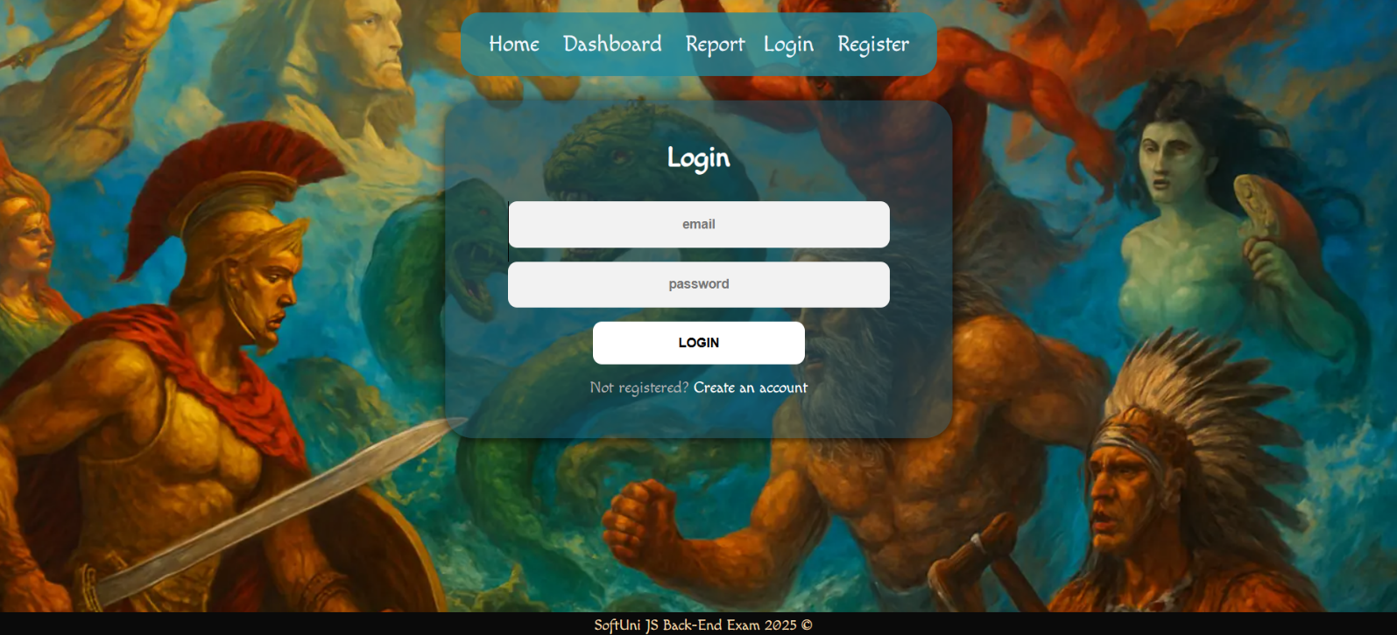

#### Logout (Logged in user)

The logout action is available to **logged-in** users. Upon success, clear any session information and **redirect** the user to the **Home** page.

A user who is **NOT** logged in should **NOT** be able to reach this functionality by typing its URL (e.g. "http://localhost:3000/logout") in the browser address bar.

#### Add Myth (Logged in User)

The **Add Myth** page is available to **logged-in users**. It contains a form for adding new myth or legend. Upon success, **redirect** the user to the **Dashboard** page. If the user tries to submit **invalid data**, an **error message** should be displayed and the already entered **data should be kept** in the input fields.

A guest user (who is not logged in) should **NOT** be able to reach this page by typing its URL (e.g. "http://localhost:3000/myths/create/1234") in the browser address bar.

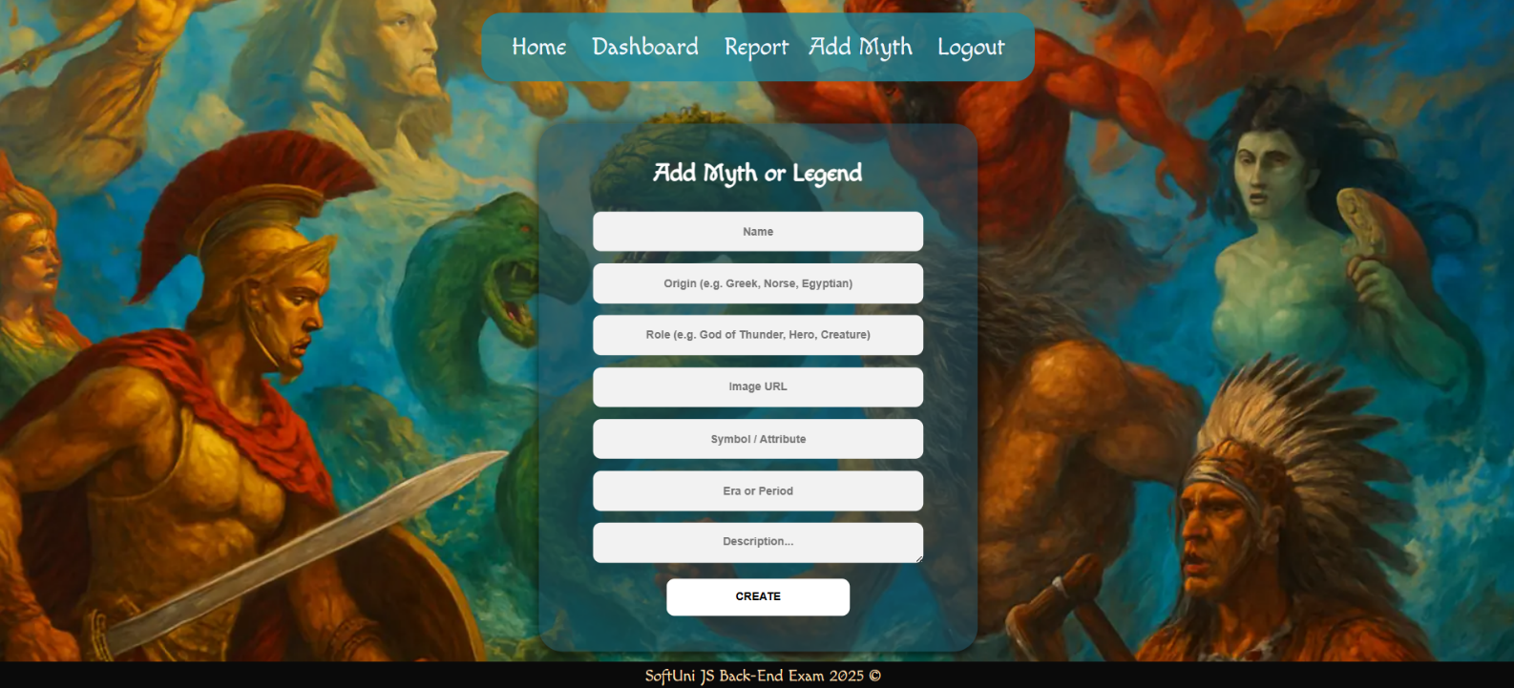

#### Dashboard (For logged in users and logged out users)

A list of all myths post. Each myth must be displayed with the **myth image**, the **name**, the **origin,** the **Role**, and a button for **details** about the **specific post**. As in the picture below:

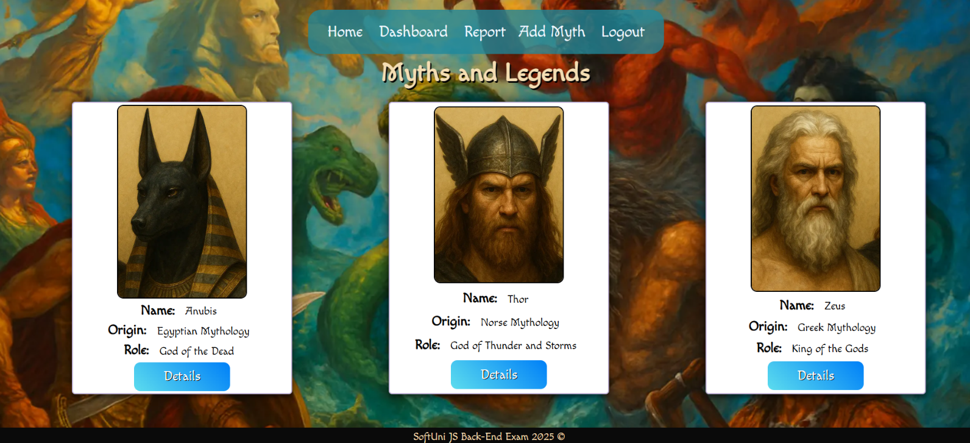

The [**Details**] button should be a link to the **details** **page** for the current myth post.

If there are **NO** posts…, display **"There are no myths and legends"**

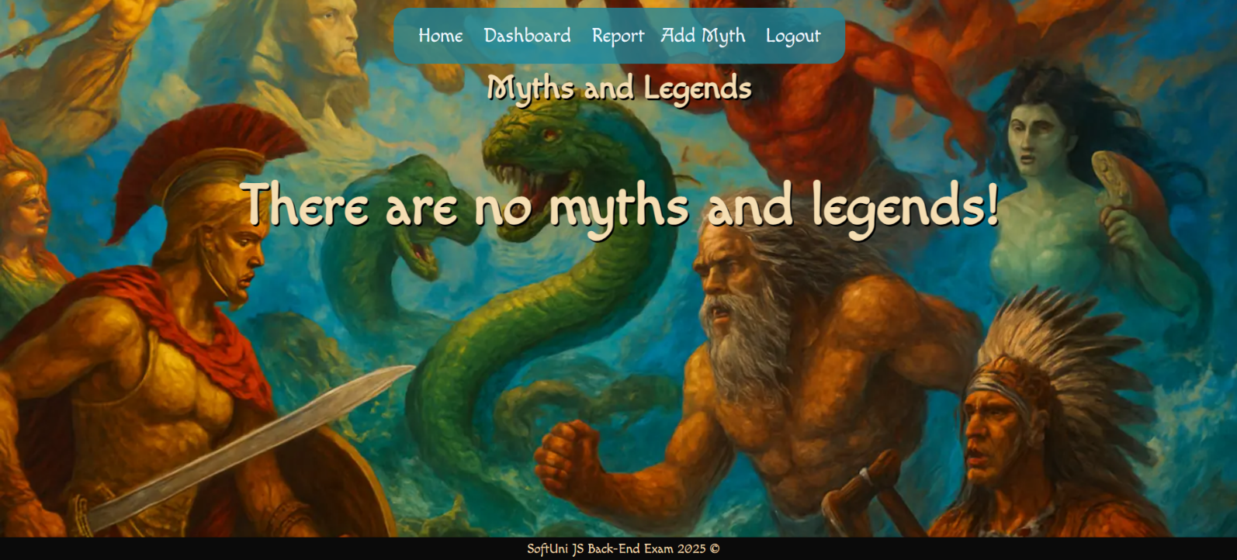

#### Details Page (For logged in users and logged out users)

All users should be able **to see the details about the myths**. Clicking the **Details button** on the post card should display the details page. If the currently registered user **is the creator** of the myth post, the **Edit** and **Delete** buttons should be displayed. Otherwise, they **should not be available**.

Information about the myth:

* **Name**
* **Origin**
* **Role**
* **Symbol**
* **Era**
* **Description**
* **Buttons** (Depending on the status of the currently logged in user)

#### Details Page (Logged out users)

If the user has not **logged in**, **no buttons** should be displayed.

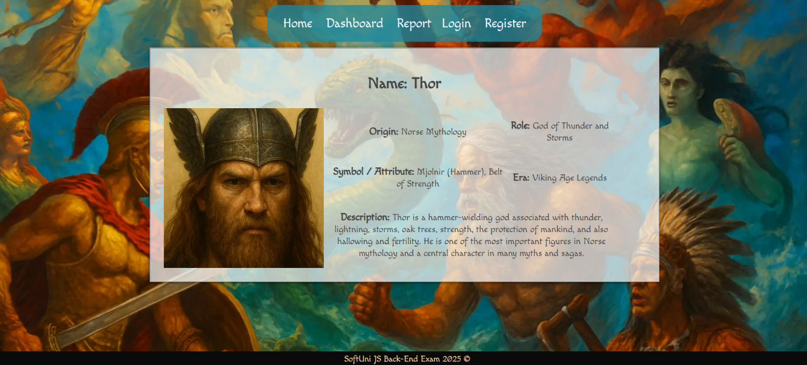

#### Details Page (Logged in user and creator of the current post)

If the **currently logged-in** user is the **owner** (the user who **created the myth post**), he should see the **[Delete]** and **[Edit]** buttons.

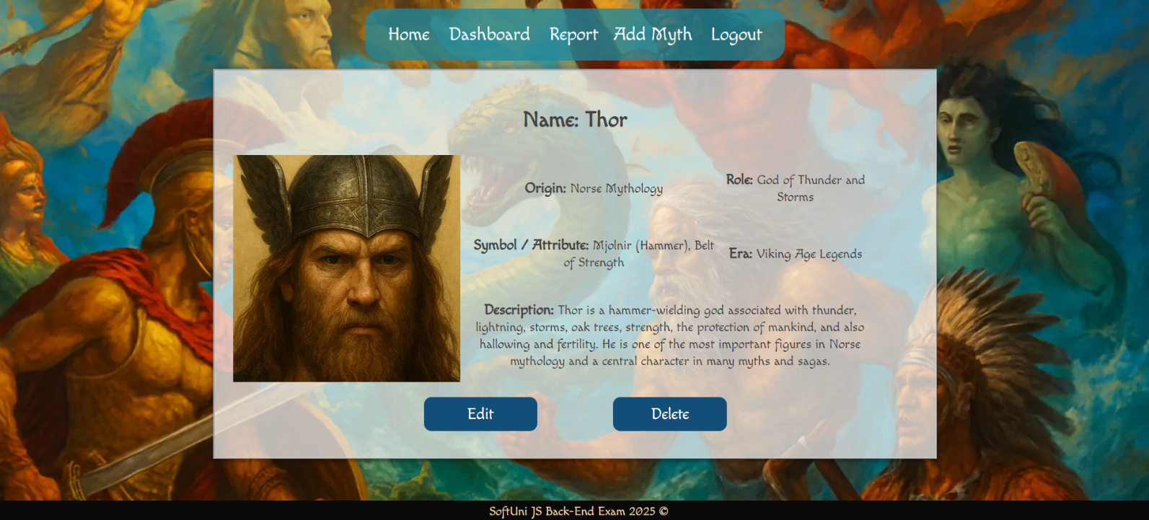

#### Details Page (Logged in user who has not liked myth post)

If the currently logged-in user is **not the owner** (a user who is **not** the creator of this myth post) and **he has not liked post**, he should see a **Like** button.

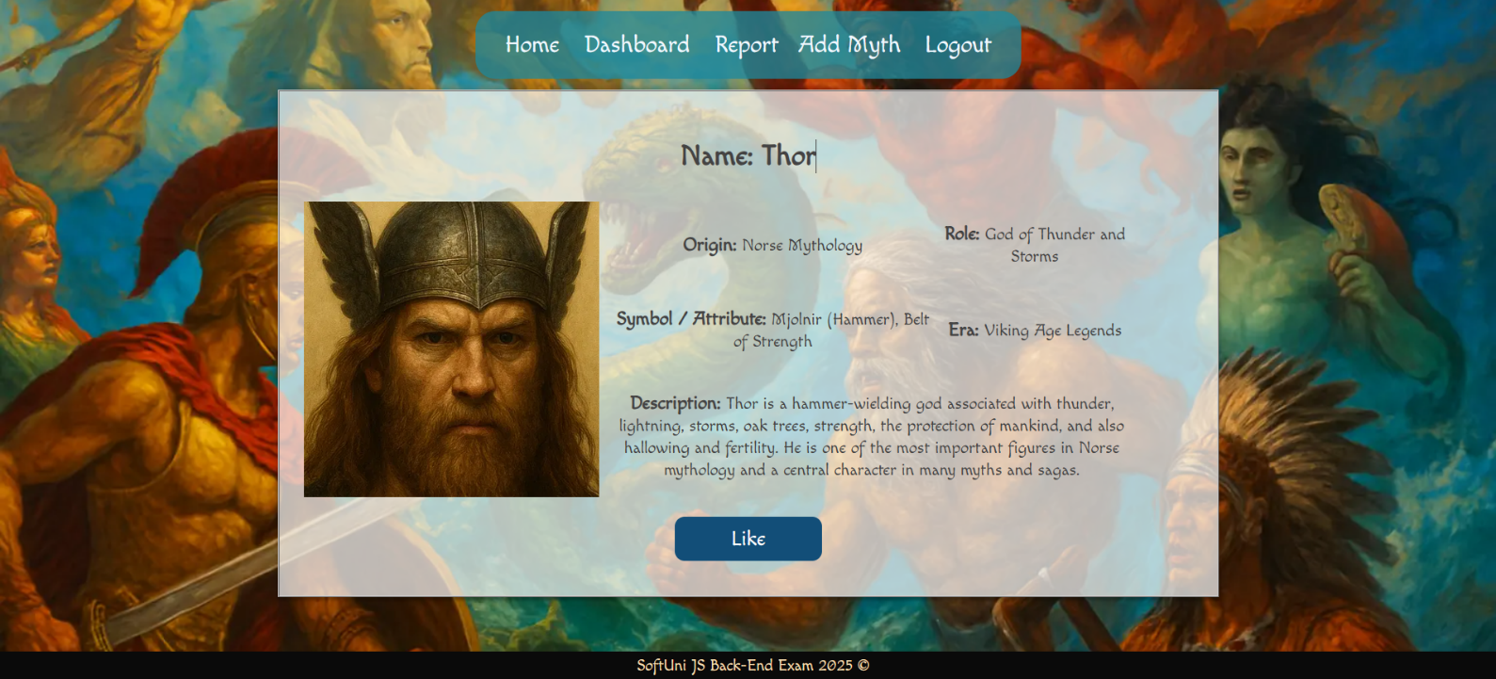

#### Details Page (Logged in user already liked myth post)

If the currently logged in user **is not the owner** and has **already liked myth post**, he should see **[You've already liked this legend!].**

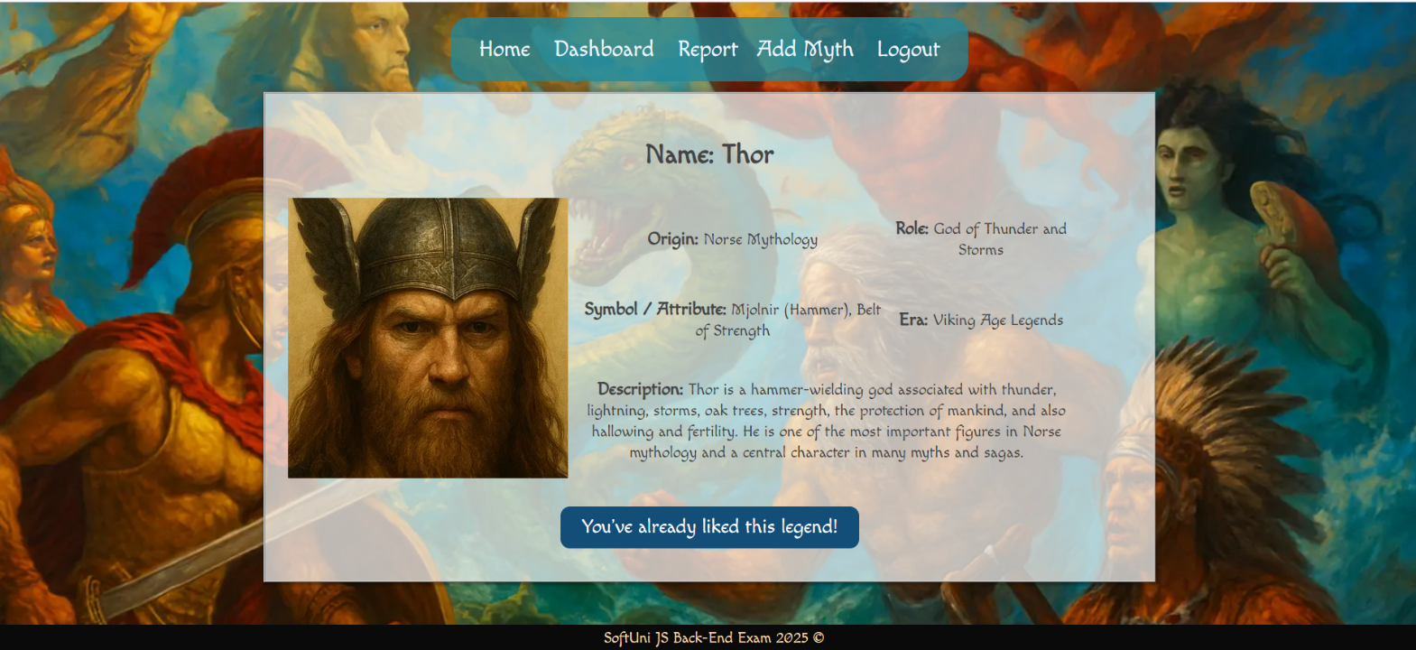

#### Delete Myth Post (Logged in user and owner of the current post)

Each **owner** of the myth post must be able to click on the **[Delete]** button and **delete the current myth post** from the database. After this, the user must be redirected to the **Dashboard** page.

A user who is not the owner of the myth should **NOT** be able to reach this functionality by typing its URL (e.g. "http://localhost:3000/myths/delete/1234") in the browser address bar.

#### Edit Myth Post (Logged in user and owner of the current post)

Each **owner** can edit their **myth post**. Clicking the **[Edit]** button for a specific post on the details page should display the **Edit page**, all fields being populated with myth data. It contains a form with input fields for all relevant properties. If **successful**, redirect the user to the **current myth post details page**. If the user tries to submit **invalid data**, an **error message** should be displayed and the already entered **data should be kept** in the input fields.

A user who is not the owner of the myth should **NOT** be able to reach this page by typing its URL (e.g. "http://localhost:3000/myths/edit/1234") in the browser address bar.

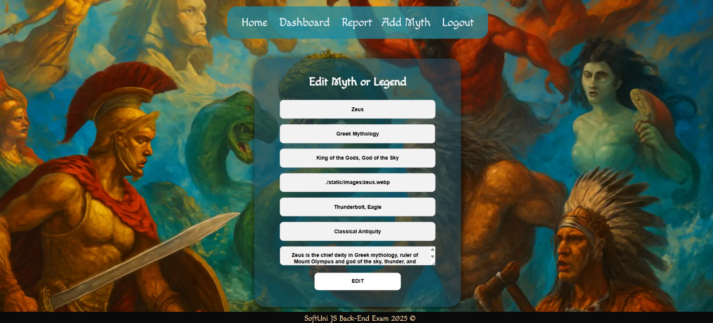

## Security Requirements (Routes Guards)

The Security Requirements are mainly **access** requirements. Configurations about which users can access specific functionalities and pages.

* Guest (not logged in) users can access the Home page.
* Guest (not logged in) users can access the Login page and functionality.
* Guest (not logged in) users can access the Register page and functionality.
* Guest (not logged in) and Users (logged in) can access the **Dashboard** (Listed all myth posts).
* Guest (not logged in) and Users (logged in) can access the **Report**.
* Guest (not logged in) can access the **Details** page without functionality.
* Users (logged in) can access the Home page.
* Users (logged in) can access the Details page and functionality.
  + **Users** (not myth post owners) can **like other post**.
  + **Users** (myth post owners) can **Edit** and **Delete** the current myth post
* Users (logged in) can access the **Add Myth** page and functionality.
* Users (logged in) can access the Logout functionality.

Use the following view for **invalid** **paths**:

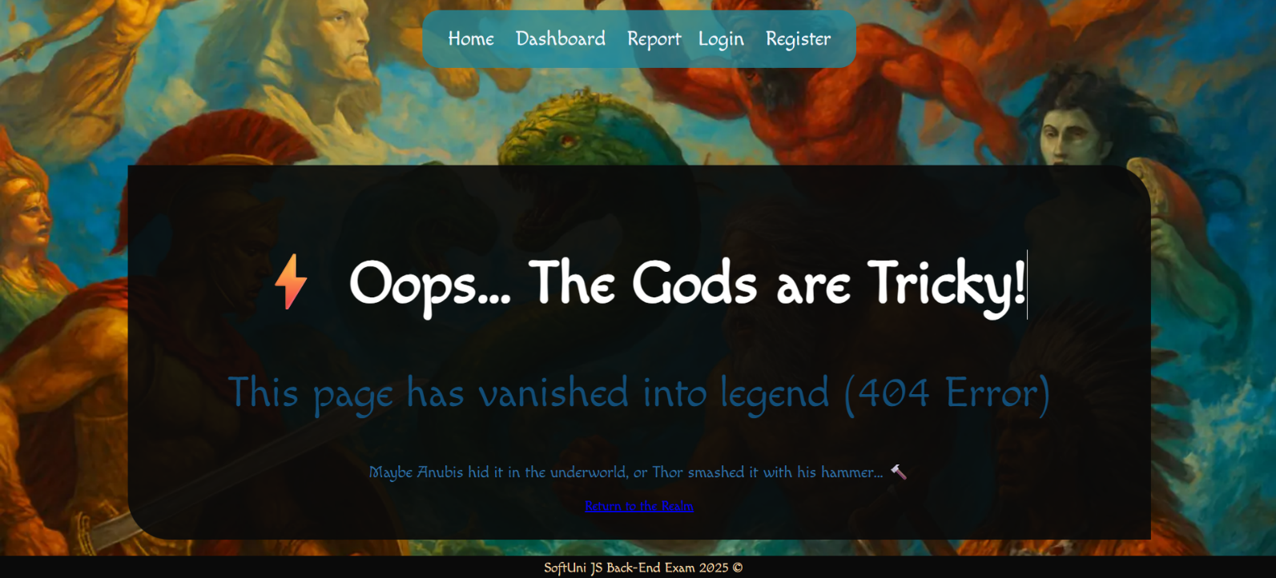

## Validation and Error Handling

### The application should notify the users about the result of their actions.

In case of error, you should display div with class "**errorContainer**"

### You can choose to display the first error or all of them. You have complete freedom to choose the content of the error message you will display, as long as it is clear what exactly the error is.

### Login / Register

You should make the following validations:

* The **email** should be **at least 10 characters** long
* The **password** should be **at least 4 characters** long
* The **repeat password** should be **equal to the password**

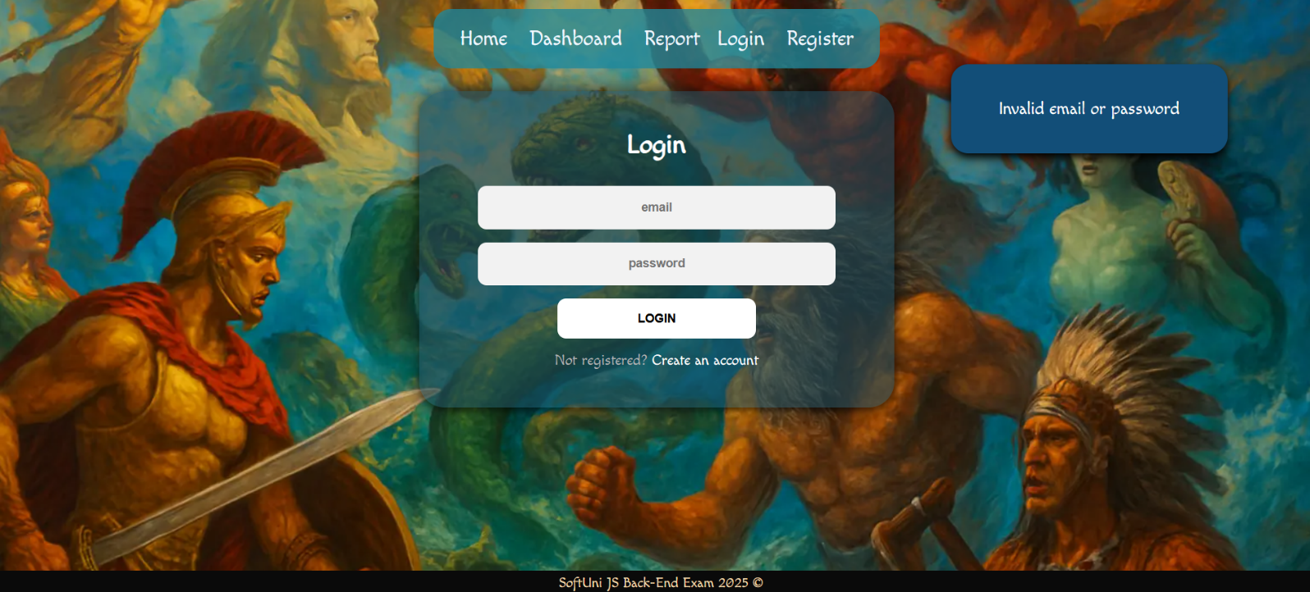

### Myths

You should make the following validations while **creating** or **editing a** **myth post**:

* The **Name** should be **at least 2 characters**
* The **Origin** should be **at least 3 characters**
* The **Role** should be **at least 2 characters**
* The **Symbol** should be **between 3 and 40 characters**
* The **Era** should be **between 5 and 15 characters**
* The **Description** should be a minimum of **10 characters** **long**
* The **Myth Image** should start with **http:// or https://**

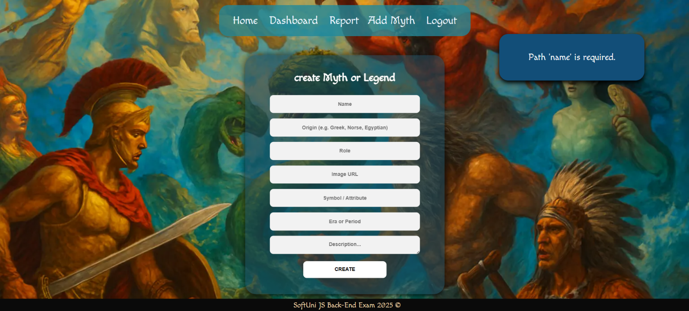

## * Bonus – REST API Endpoint

### Objective

Implement a **REST API** endpoint that allows external clients to retrieve the latest myths in JSON format. This endpoint will provide dynamic data for the **Report page**.

### Endpoint Specification

You can make request to the following endpoint:

* Latest Myths (GET): [**http://localhost:3000/api/report/myths/latest**](http://localhost:3000/api/report/myths/latest)

Return the **3 most recently added myths**, sorted by **createdAt** in descending order.

**Each** myth must include:

* **name**
* **origin**
* **role**
* **symbol**
* **era**
* **image**
* **ownerEmail**
* **createdAt**

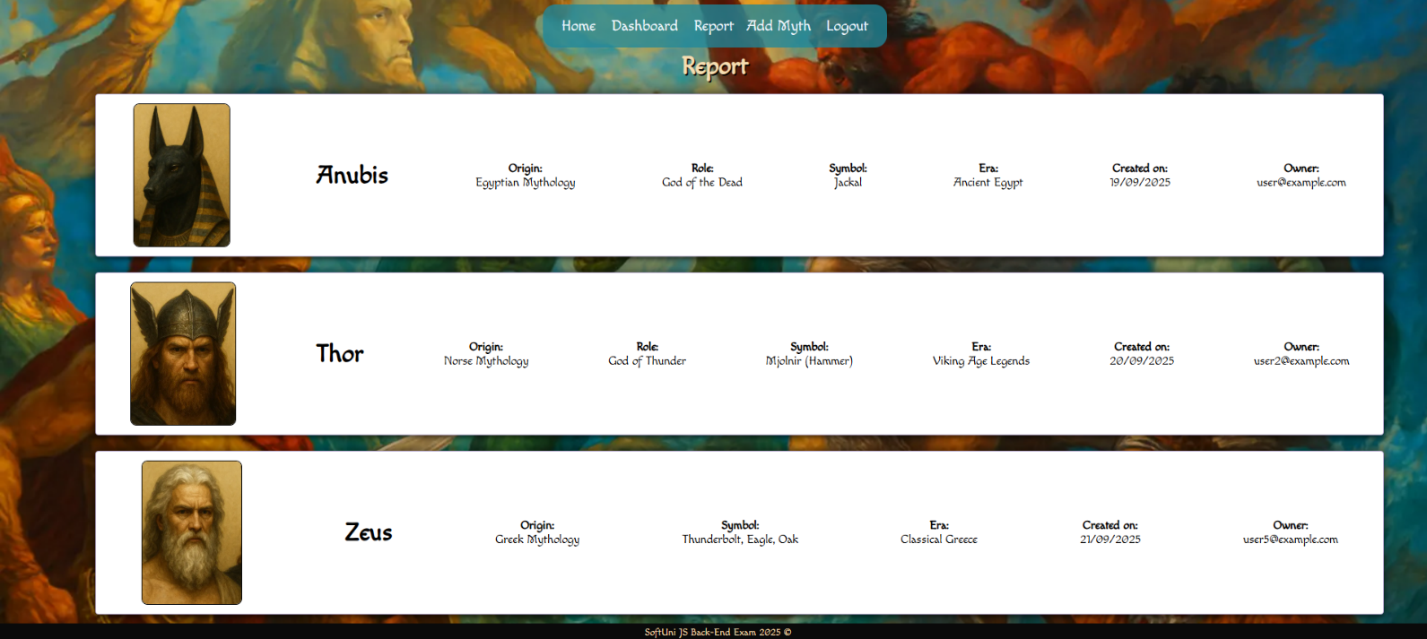

### Access Requirements

* Endpoint must be **publicly accessible**.
* No authentication required.

### Front-End Integration

* Dynamically populate the **Report page** with myth cards.
* Each card must display: image, name, origin, role, symbol, era, createdAt, and ownerEmail.
* All dates returned by the API (**createdAt**) must be displayed in a human-readable format, e.g., DD/MM/YYYY.
* If no myths exist, display **h2 tag "There are no myths and legends!"**.

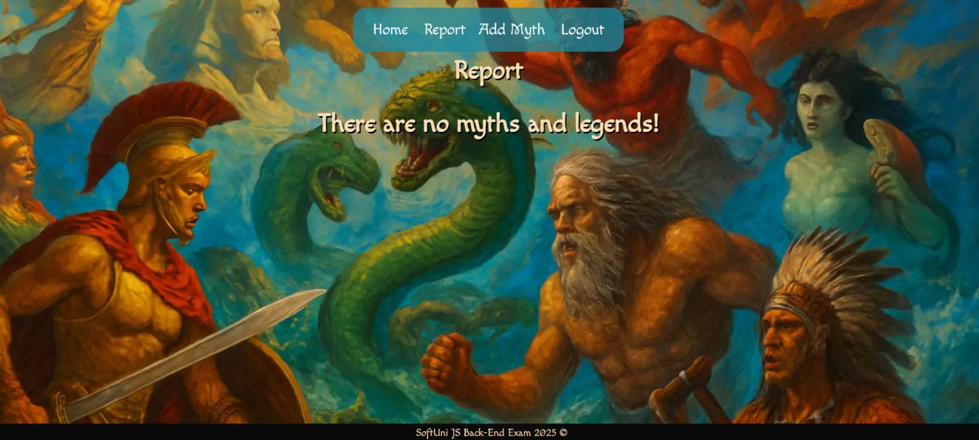

### Error Handling

* On server error, display **h2 tag** **"Error loading report!"**.

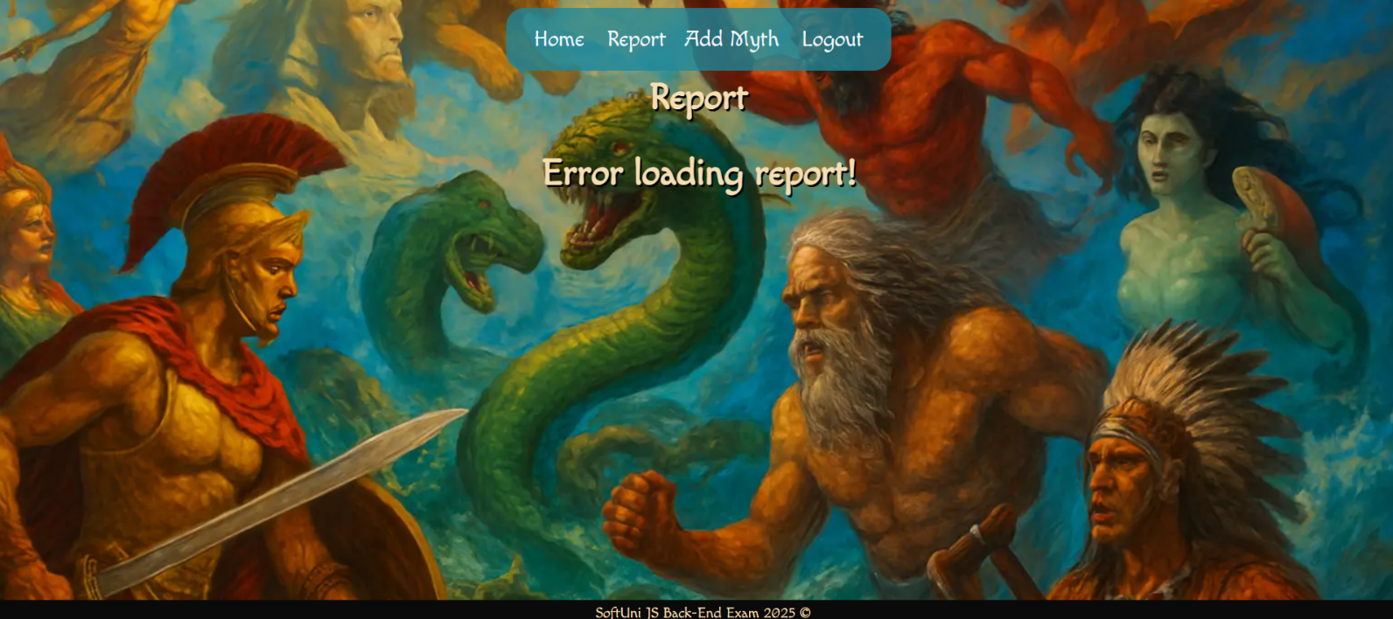

*GOOD LUCK! 😊*